Airvistara-Elearning

ExternalUser-UserDocument

1. Web Site : <http://52.76.197.92/>

<http://52.76.197.92/> link will direct user on Airvistara Home Page having information about Airvistara Company & asking user for “Login” if user already exist And “Registration” if user is new & not company employee & as external user he/she want to take training for course available in Airvistara.

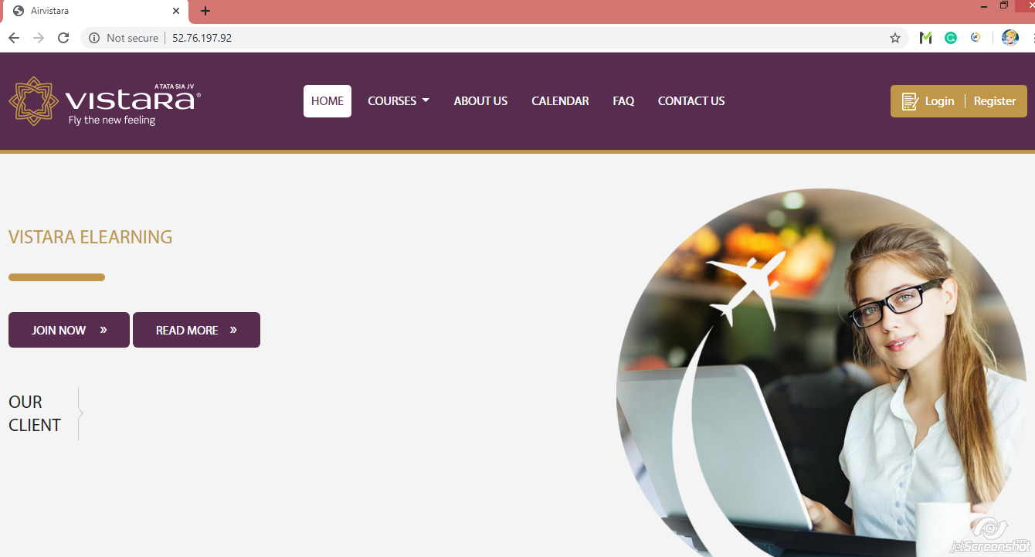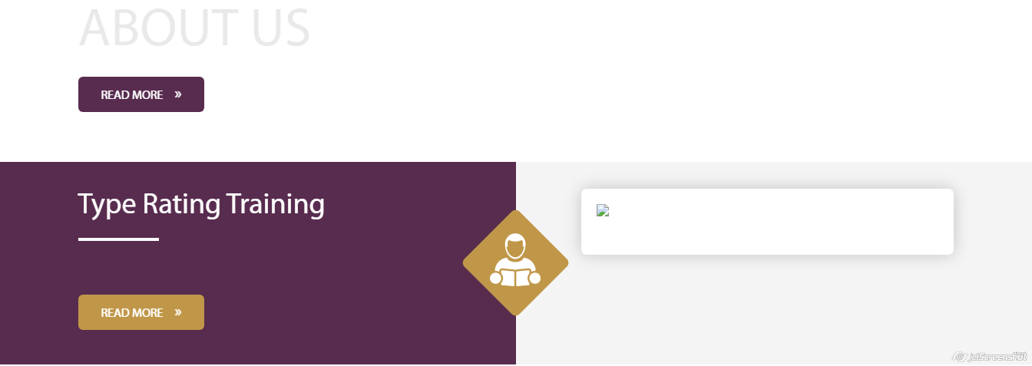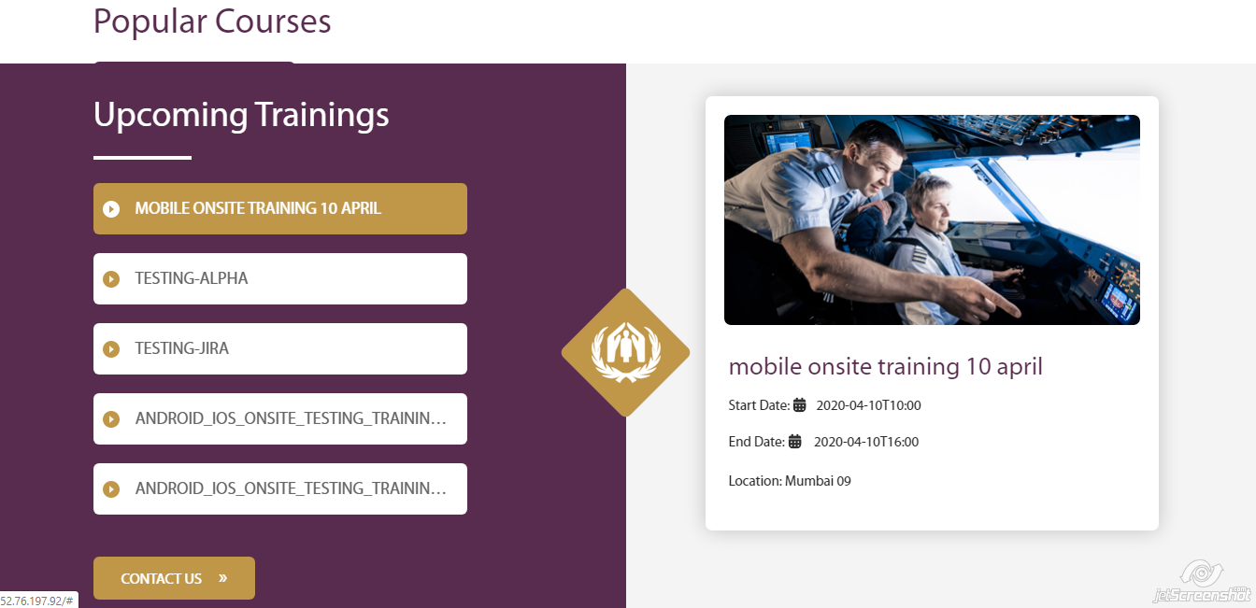

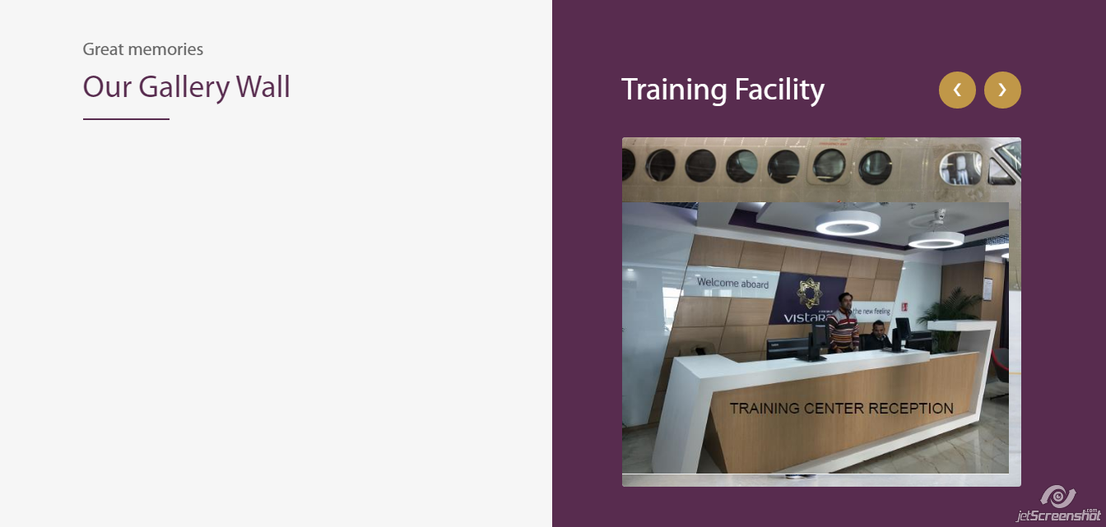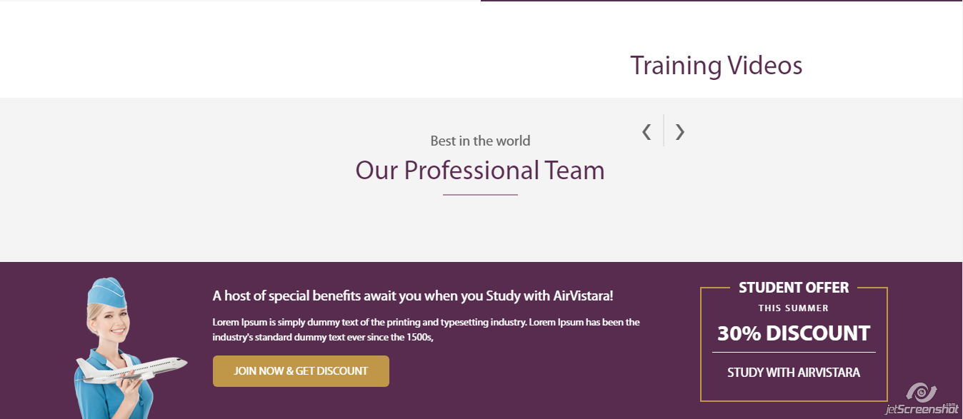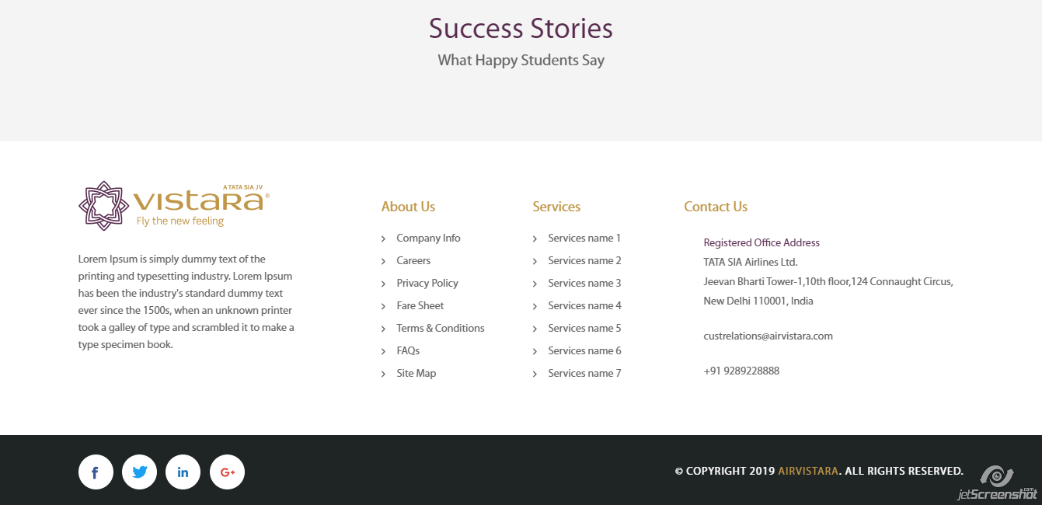

2) Registration

When any user other than Airvistra employee want to visit or take admission for vistara courses should have to register 1st & after clicking on “Registration” button on home page it direct user for registration form asking some miner information about user like his/her first name, last name, email & password for registration.

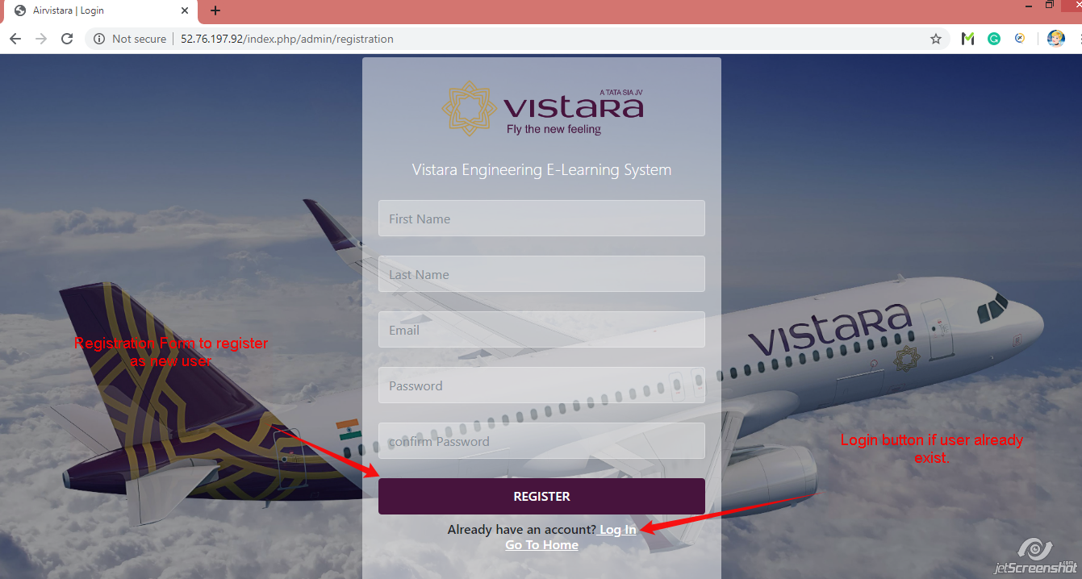

3) Login Page

When registration is successful, it direct user on login page asking for email id & password And after clicking on login button it direct user on User Home Page.

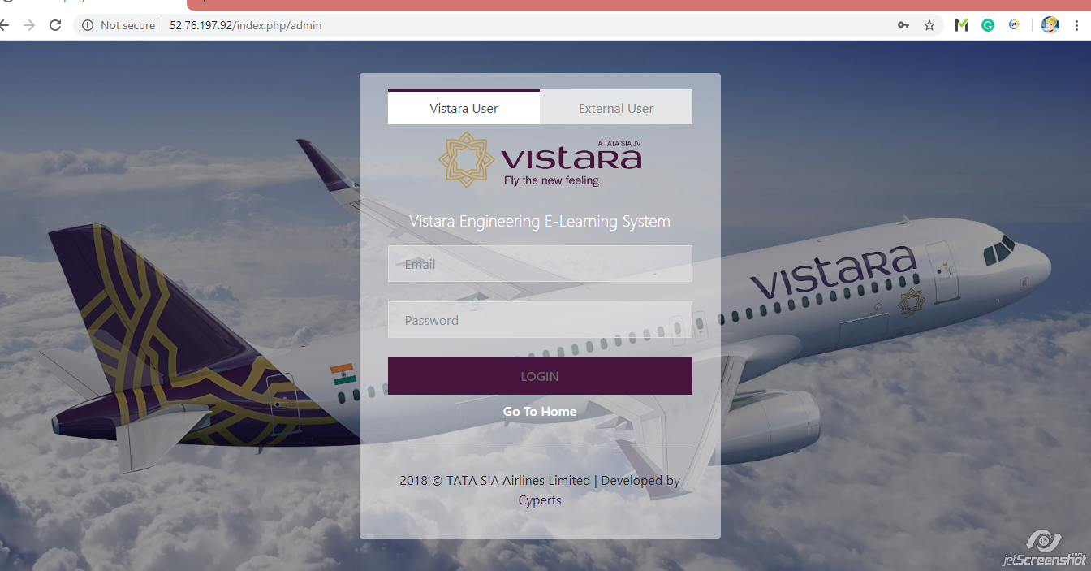

4) Home Page

When user login with all valid credentials, It direct user on “User Home Page” giving information about “Recent News” with dashboard images & calendar showing all plan courses.

Also user home having information about “Dashboard” , User Cart with his/her perches, Notification bell & so on.

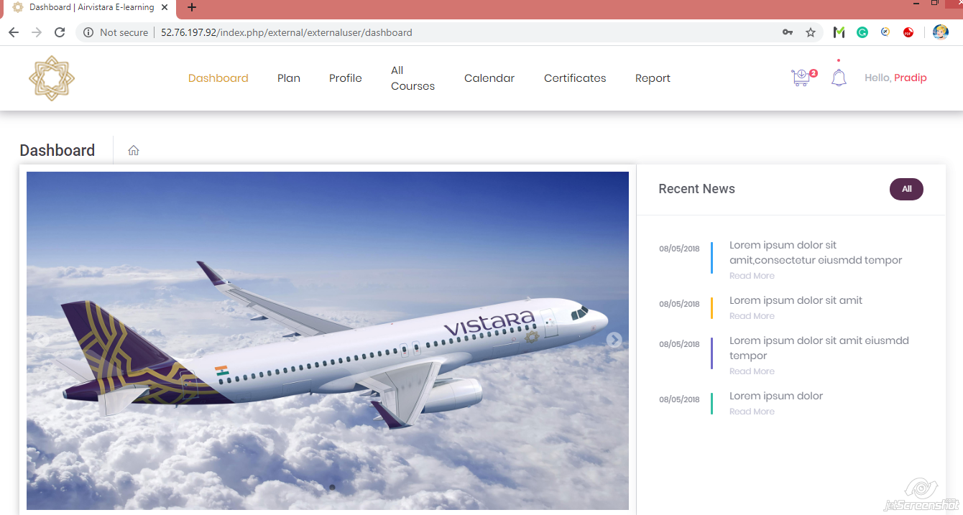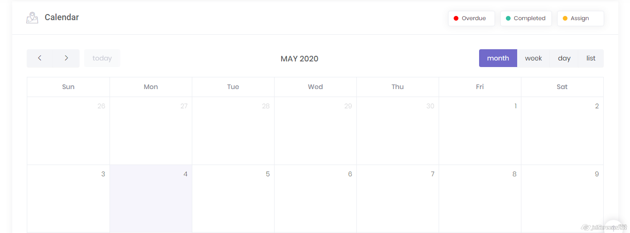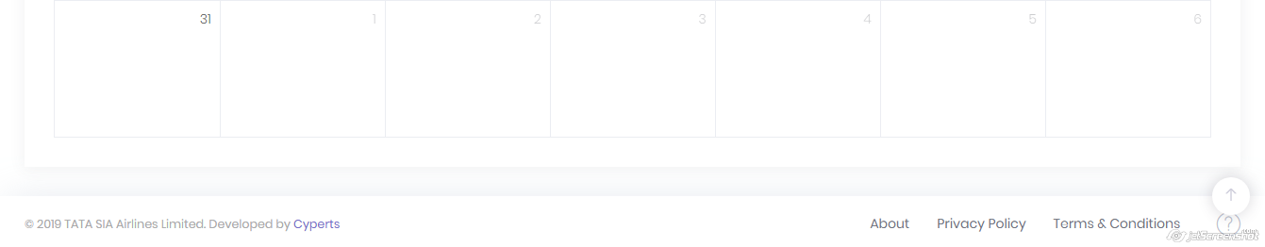

5) Home Page 🡪 Notification

When user click on “Notification” bell on user home page, It opens a list of notification giving information to user about his/her assign courses, Overdue courses, Completed courses.

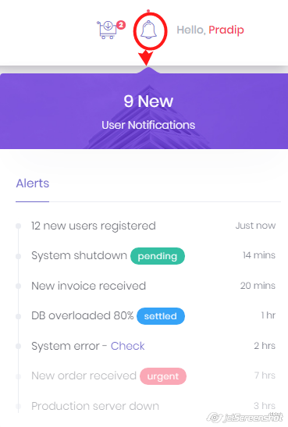

6) Home Page 🡪 Plan

Plan tab on User Home Page direct user on page asking user to give information about which plan he/she want to select from “Individual Plan” & “Enterprise Plan” So that it can direct user for profile as per plan.

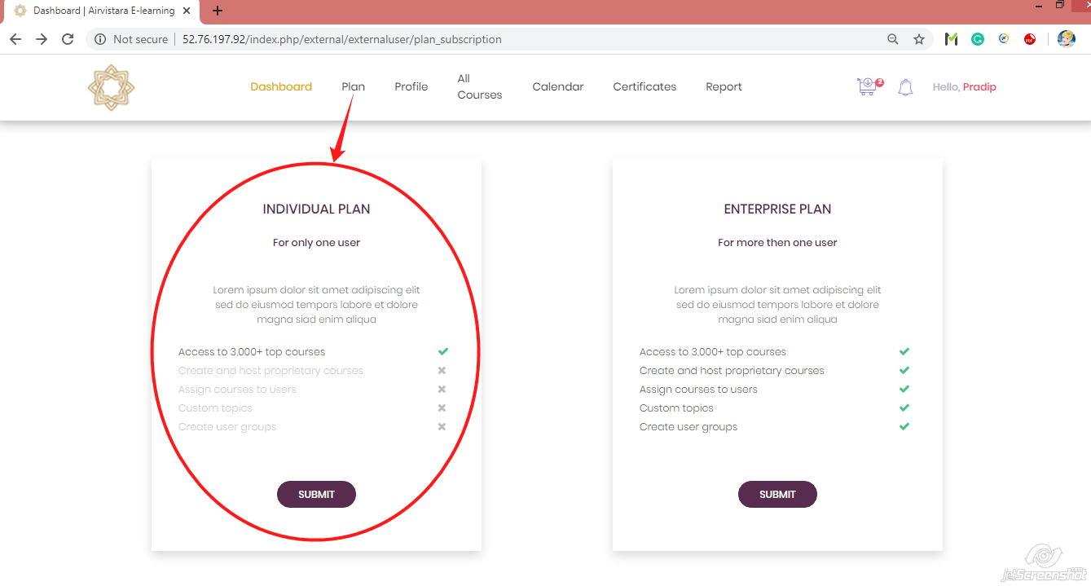

7) Home Page 🡪 Plan 🡪 Individual Plan 🡪 Submit button 🡪 Profile

After selecting “Individual Plan” from plan page it direct user on page asking information about users profile for Personal, Company, Qualification, BAMEL/BAMEEC/Modules, License, Authorization Details, Previous Employer & Resume. Here user should have to fill all required information.

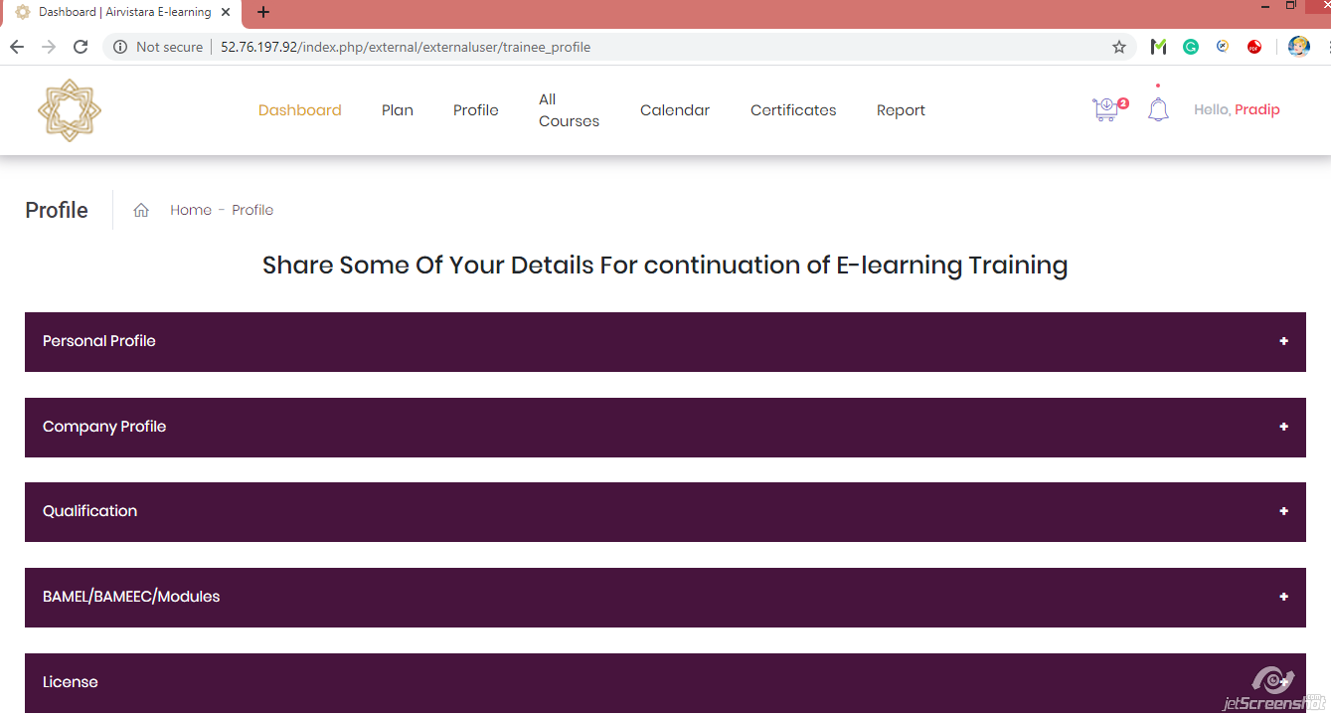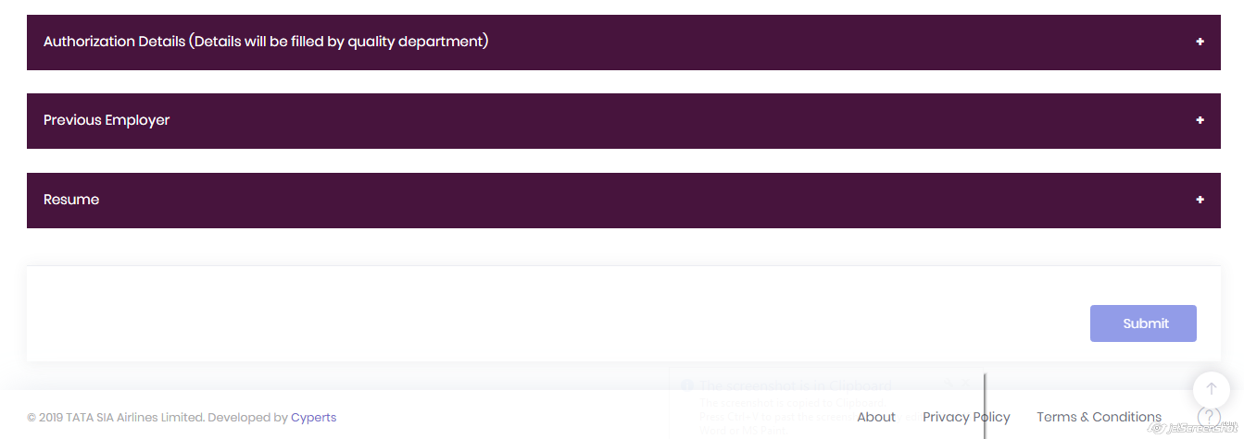

8) Home Page 🡪 Plan 🡪 Individual Plan 🡪 Submit 🡪 Profile 🡪 Personal Profile

When user click on “Personal Profile” tab it open form showing users personal data fill in registration form with “Edit Profile” button to fill some required information.

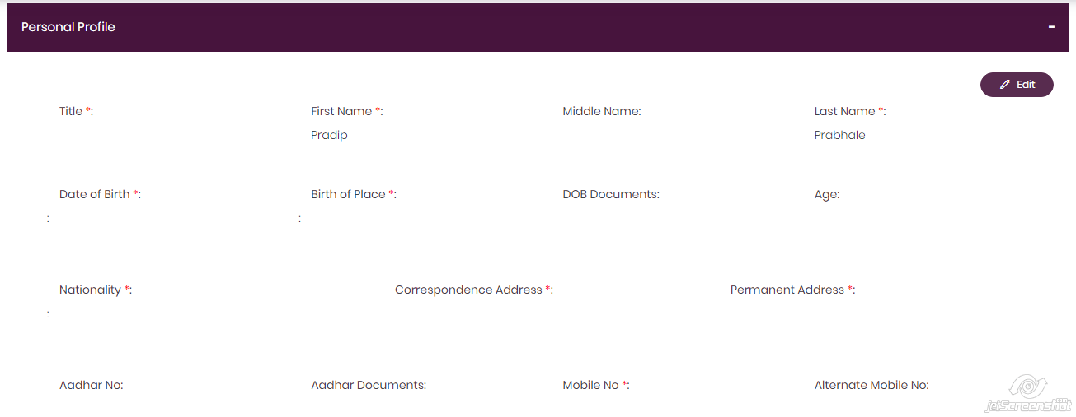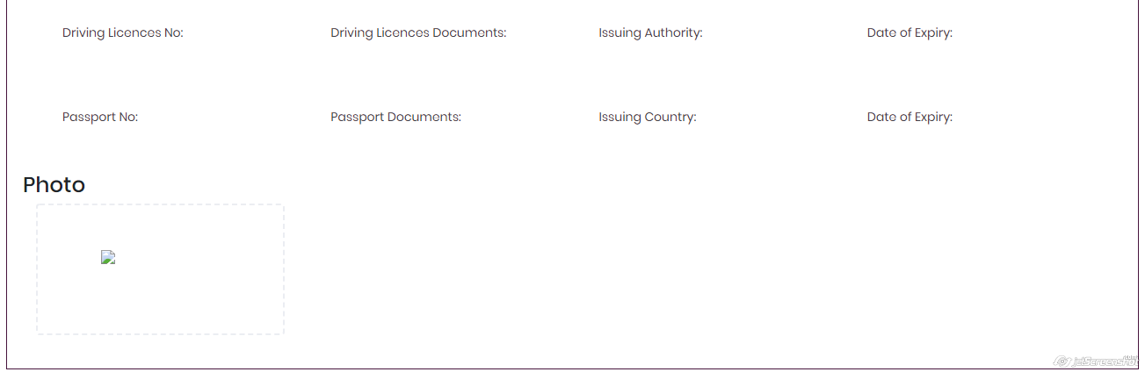

9) Home Page 🡪 Plan 🡪 Individual Plan 🡪 Submit 🡪 Profile 🡪 Personal Profile 🡪 Edit

When user click on “Edit” button it direct user on form with personal information in editable mode to fill all required information about user.

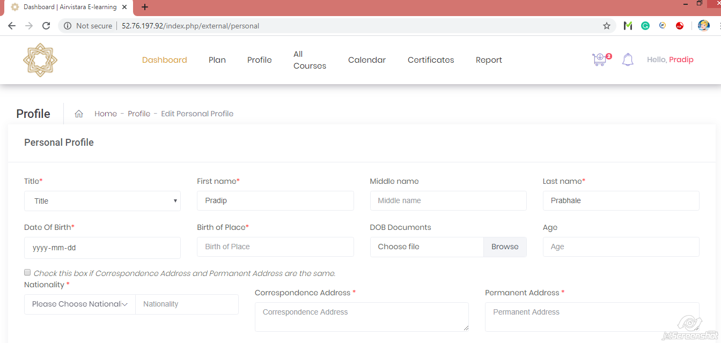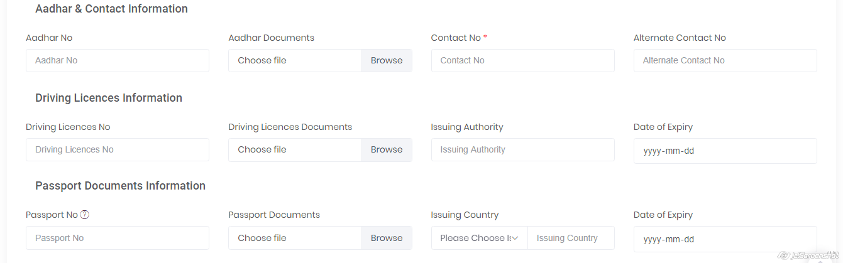

10) Home Page 🡪 Plan 🡪 Individual Plan 🡪 Submit 🡪 Profile 🡪 Company Profile

When user click on “Company Profile” tab it open form showing users company data with “Edit Company” button to fill some required information.

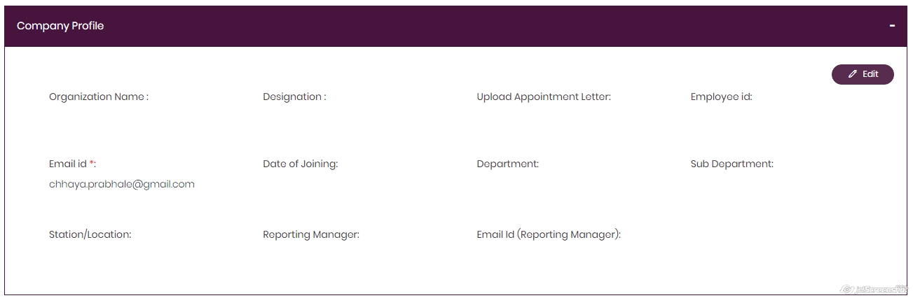

11) Home Page 🡪 Plan 🡪 Individual Plan 🡪 Submit 🡪 Profile 🡪 Company Profile 🡪 Edit

When user click on “Edit” button it direct user on form with company information in editable mode to fill all required information about Users Company.

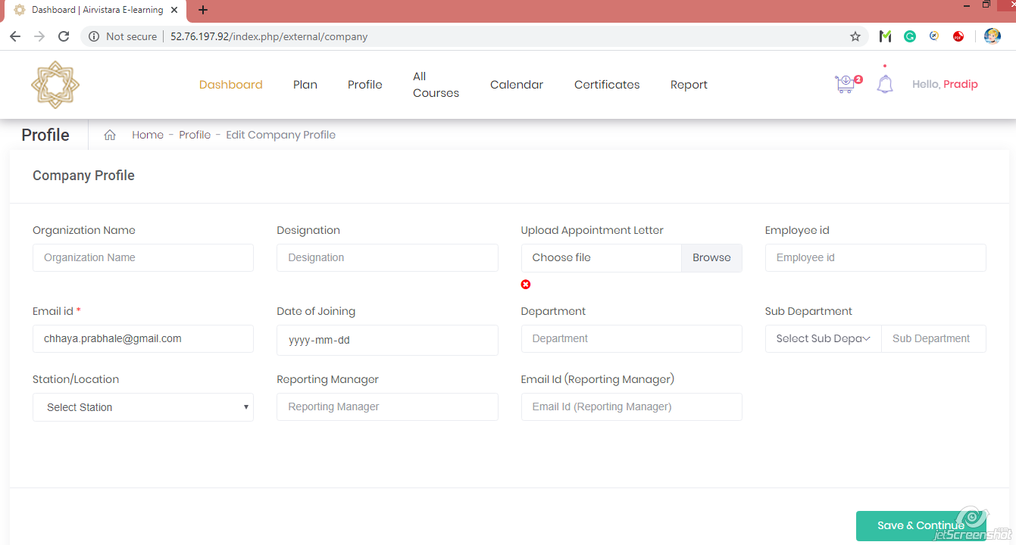

12) Home Page 🡪 Plan 🡪 Individual Plan 🡪 Submit 🡪 Profile 🡪 Qualification

When user click on “Qualification” tab it open form showing users qualification data with “Edit Qualification” button to fill some required information.

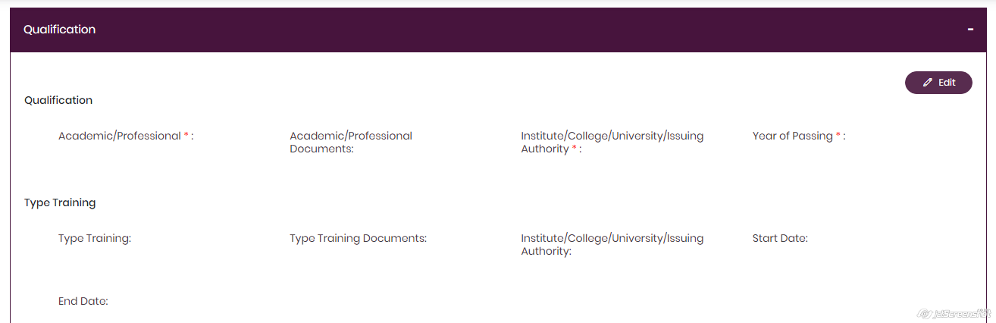

13) Home Page 🡪 Plan 🡪 Individual Plan 🡪 Submit 🡪 Profile 🡪 Qualification 🡪 Edit

When user click on “Edit” button it direct user on showing 3 types of tab to add qualification information with “Users Basic Qualification”, “Type Training” & “Additional Certification/Trainings” to add as users qualification.

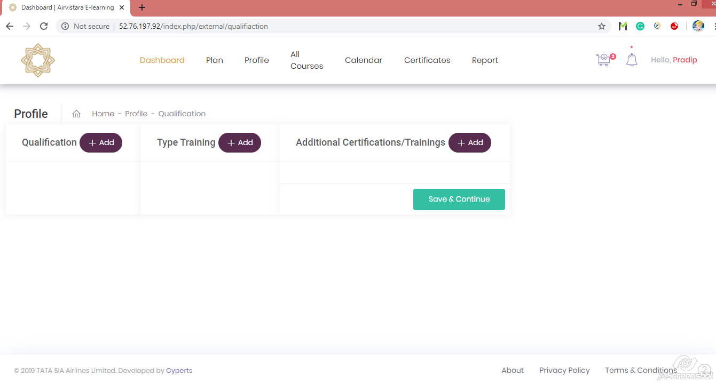

14) Home Page 🡪 Plan 🡪 Individual Plan 🡪 Submit 🡪 Profile 🡪 Qualification 🡪 Edit 🡪 Qualification Add

When user click on “Qualification Add” button it direct user on form asking users Academic/Professional qualification with Institute/College/University/Issuing Authority with year of passing & user must have to fill all required information.

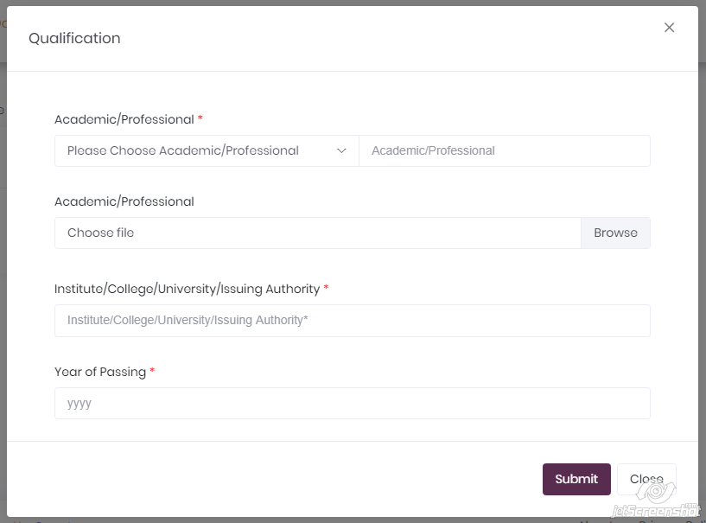

15) Home Page 🡪 Plan 🡪 Individual Plan 🡪 Submit 🡪 Profile 🡪 Qualification 🡪 Edit 🡪 Type Training Add

When user click on “Type Training Add” button it direct user on form asking users Type Training with Institute/College/University/Issuing Authority with Start date & End date.

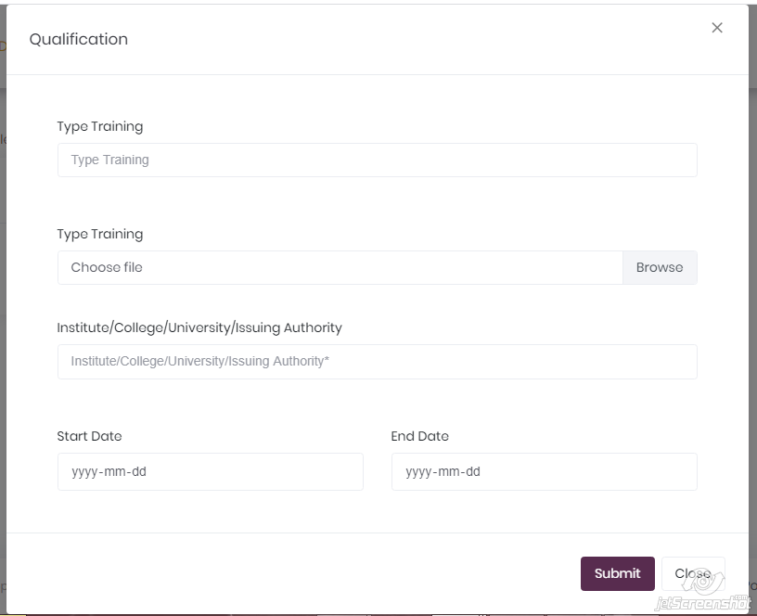

16) Home Page 🡪 Plan 🡪 Individual Plan 🡪 Submit 🡪 Profile 🡪 Qualification 🡪 Edit 🡪 Additional Certifications/ Trainings Add

When user click on “Additional Certifications/ Trainings Add” button it direct user on form asking users Additional Certifications/ Trainings with Iinstitute /College /University /Issuing Authority with Start date & End date.

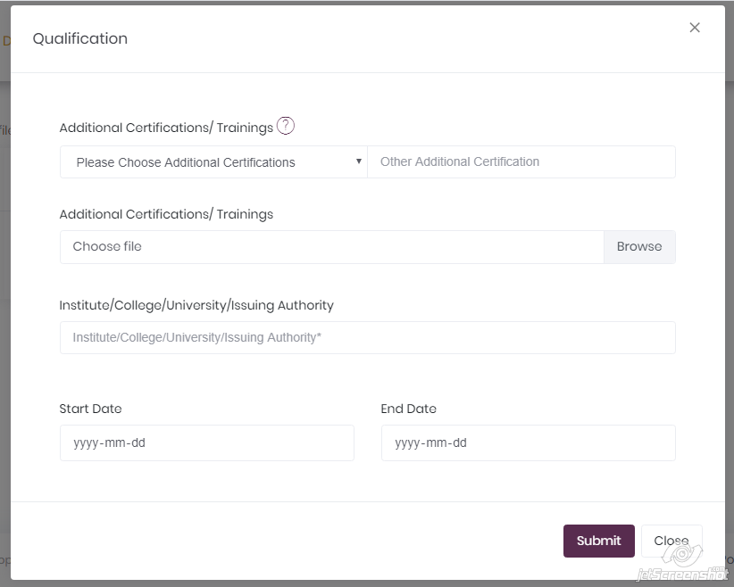

17) Home Page 🡪 Plan 🡪 Individual Plan 🡪 Submit 🡪 Profile 🡪 BAMEL/BAMEEC/Module

When user click on “BAMEL/BAMEEC/Module” tab it open form showing Compter No. E, BAMEL No, BAMEL Documents, Issuing Authority, BAMEEC No, BAMEEC Documents & so on with “Edit” button to fill some required information.

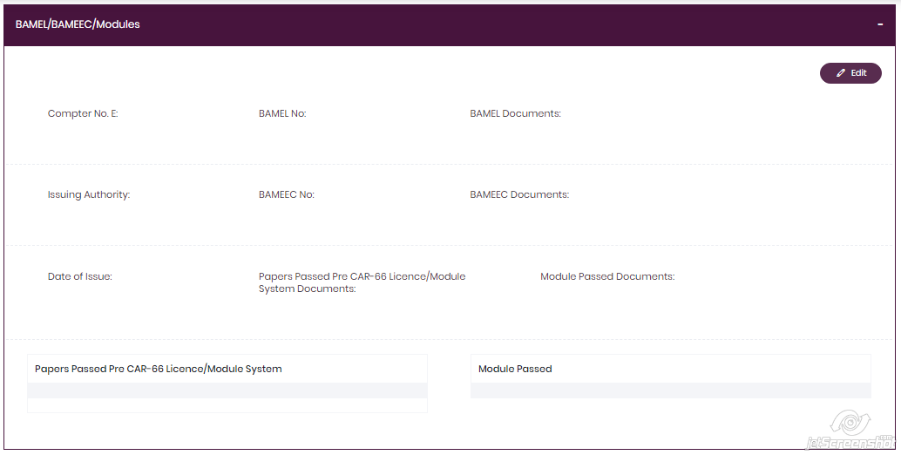

18) Home Page 🡪 Plan 🡪 Individual Plan 🡪 Submit 🡪 Profile 🡪 BAMEL/BAMEEC/Module

When user click on “Edit” button it open form showing Compter No. E, BAMEL No, BAMEL Documents, Issuing Authority, BAMEEC No, BAMEEC Documents & so on in editable mode.

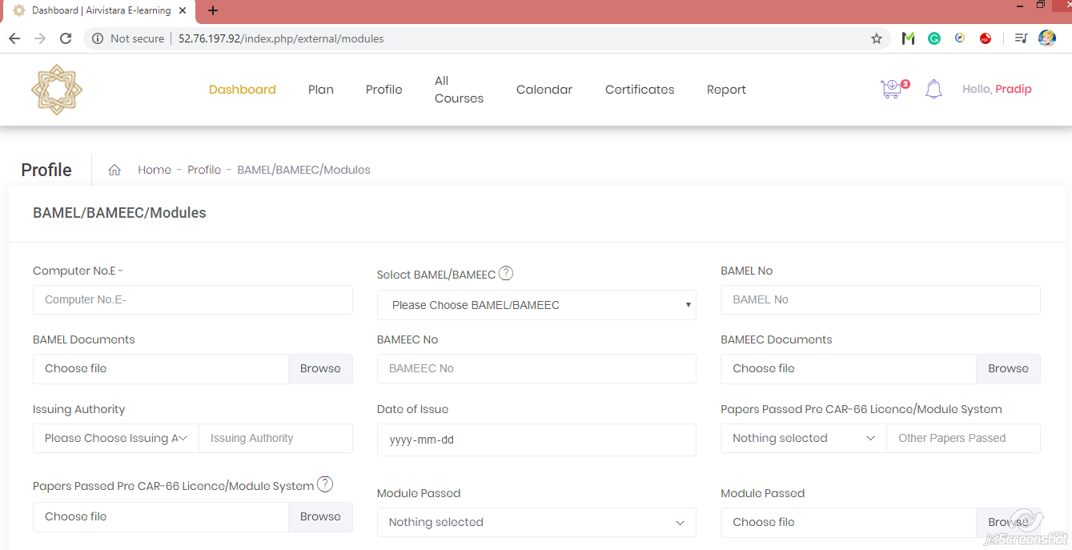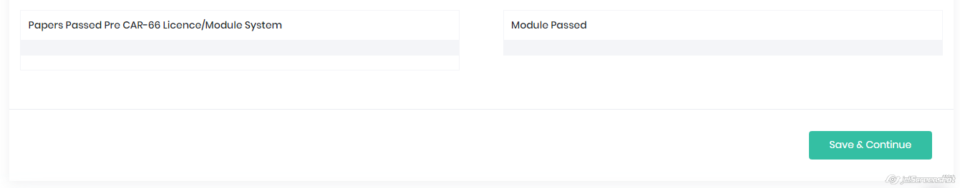

19) Home Page 🡪 Plan 🡪 Individual Plan 🡪 Submit 🡪 Profile 🡪 License

When user click on “License” button it open information about License, Type Rating, License Endorsement Inherited from AME License held prior to CAR-66 License,

RTR License Details.

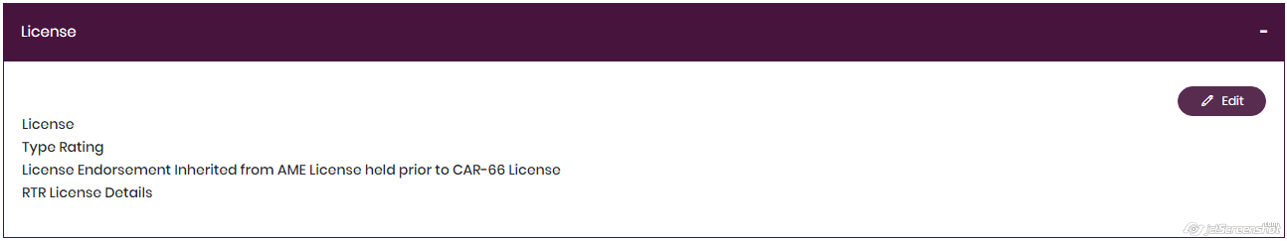

20) Home Page 🡪 Plan 🡪 Individual Plan 🡪 Submit 🡪 Profile 🡪 License 🡪 Edit

When user click on “Edit” button it open information about License, Type Rating, License Endorsement Inherited from AME License held prior to CAR-66 License,

RTR License Details in editable form.

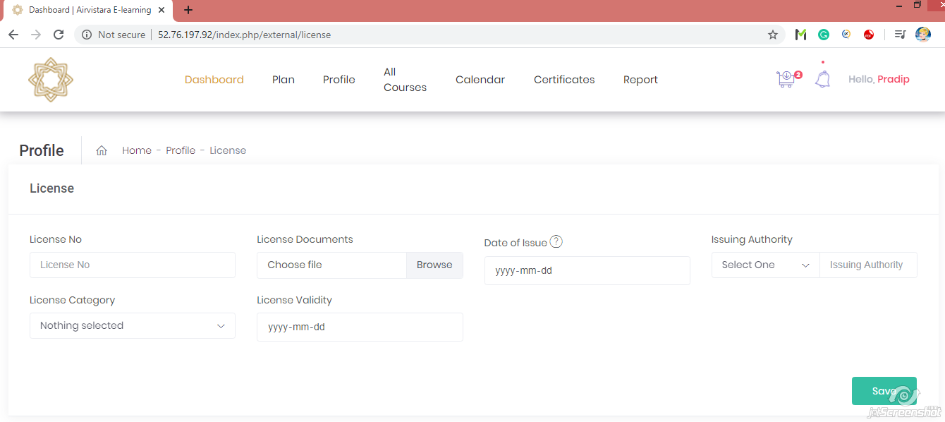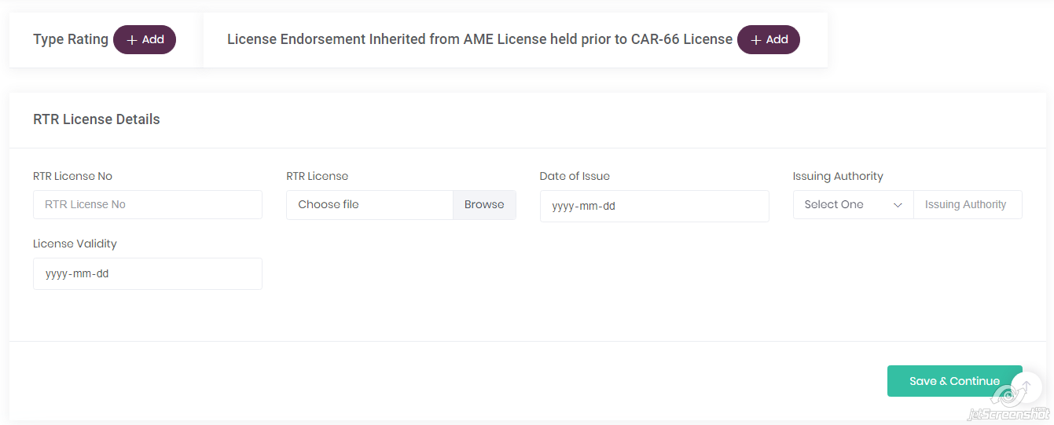

21) Home Page 🡪 Plan 🡪 Individual Plan 🡪 Submit 🡪 Profile 🡪 License 🡪 Edit 🡪 Type Rating Add button

When user click on “Type Rating” add button it direct user on form asking information about type rating with category & limitation code.

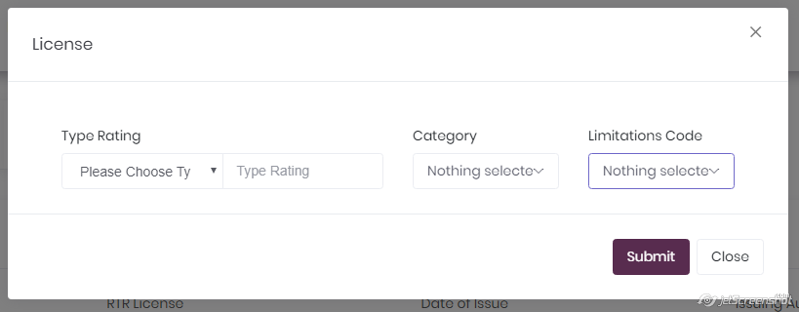

### 22) Home Page 🡪 Plan 🡪 Individual Plan 🡪Submit 🡪 Profile 🡪 License 🡪 Edit 🡪 License Endorsement Add button

When user click on “License Endorsement” add button it direct user on form asking information about type rating with category.

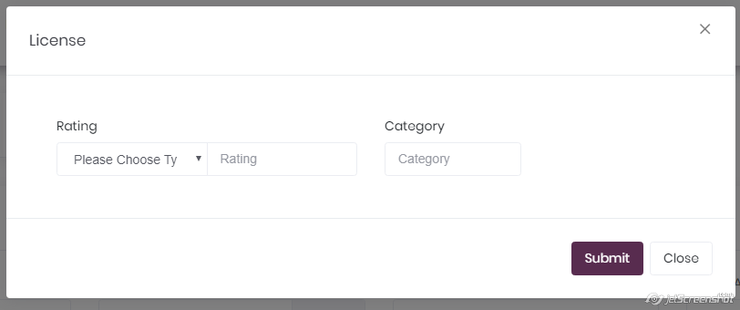

23) Home Page 🡪 Plan 🡪 Individual Plan 🡪Submit 🡪 Profile 🡪Authorization Details

When user click on “Authorization Details” tab it direct user on form showing authorization details fill by “Quality Department” & only quality department can edit this information.

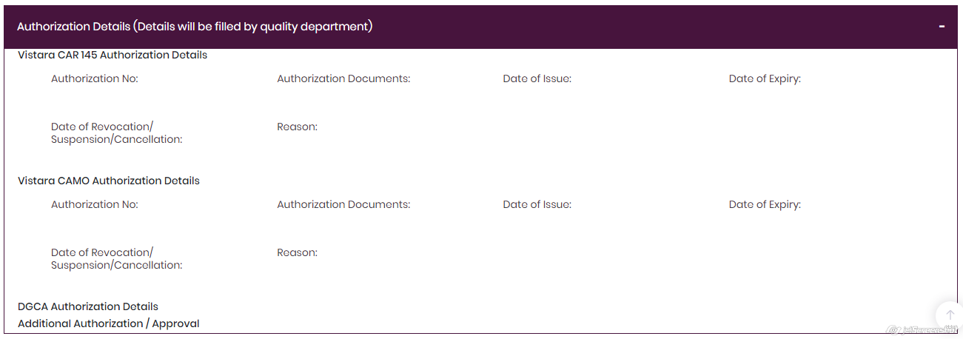

24) Home Page 🡪 Plan 🡪 Individual Plan 🡪Submit 🡪 Profile 🡪Previous Employer

When user click on “Previous Employer” tab it shows information about users previous employer with “Edit” button.

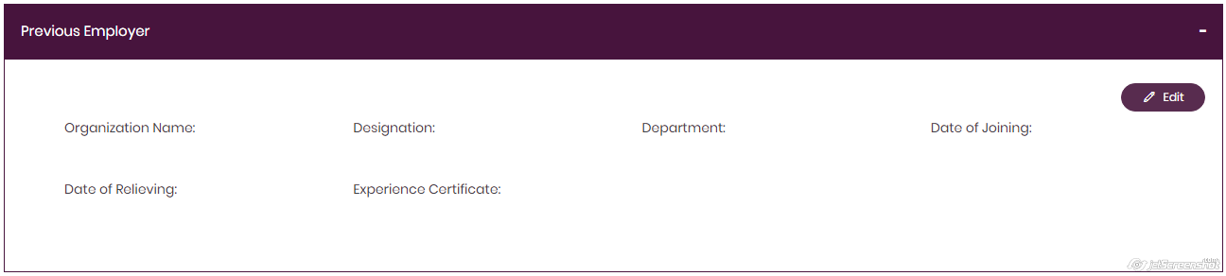

25) Home Page 🡪 Plan 🡪 Individual Plan 🡪Submit 🡪 Profile 🡪Previous Employer 🡪 Edit

When user click on “Edit” button on previous employer form it direct user on form asking to “Add” information for previous employer information.

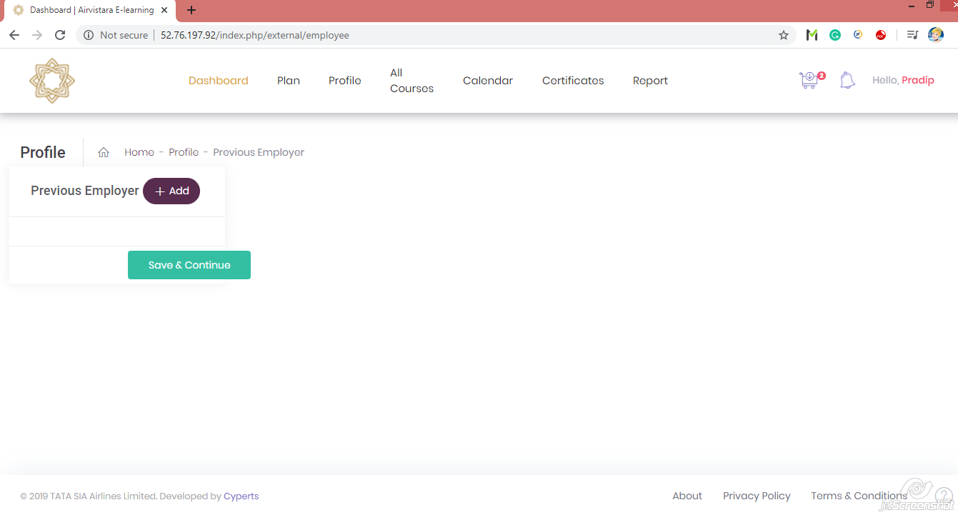

26) Home Page 🡪 Plan 🡪 Individual Plan 🡪Submit 🡪 Profile 🡪Previous Employer 🡪 Edit 🡪 Add

When user click on “Add” button on previous employer form it direct user on form asking to “Add” information for previous employer information.

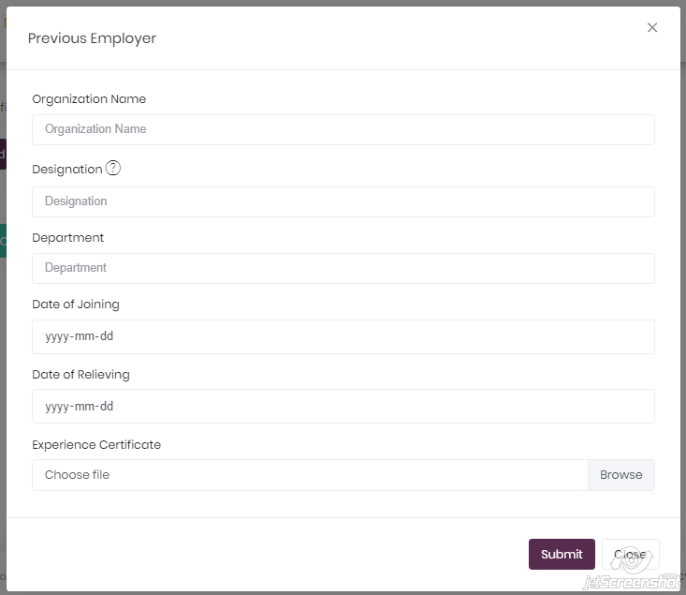

27) Home Page 🡪 Plan 🡪 Individual Plan 🡪Submit 🡪 Profile 🡪Resume

When user click on “Resume” tab it shows users resume with edit button to edit resume.

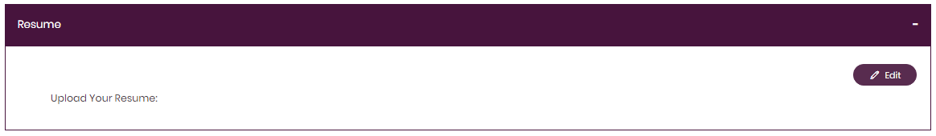

28) Home Page 🡪 Plan 🡪 Individual Plan 🡪Submit 🡪 Profile 🡪Resume 🡪 Edit

When user click on “Edit” button in Resume section it direct user on page asking for new resume to edit old one.

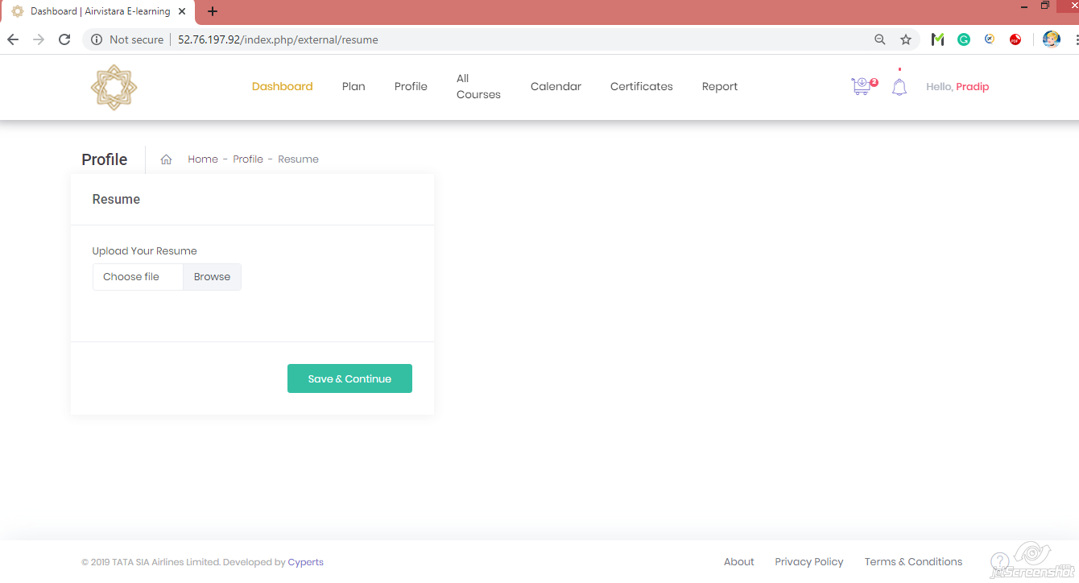

29) Home Page 🡪 Plan 🡪 Enterprise Plan 🡪 Submit button 🡪 Profile

After selecting “Enterprise Plan” from plan page it direct user on page asking information about users profile for Personal, Company, Qualification, BAMEL/BAMEEC/Modules, License, Authorization Details, Previous Employer & Resume. Here user should have to fill all required information.



30) Home Page 🡪 Plan 🡪 Enterprise Plan 🡪 Submit 🡪 Profile 🡪 Personal Profile

When user click on “Personal Profile” tab it open form showing users personal data fill in registration form with “Edit Profile” button to fill some required information.



31) Home Page 🡪 Plan 🡪 Enterprise Plan 🡪 Submit 🡪 Profile 🡪 Personal Profile 🡪 Edit

When user click on “Edit” button it direct user on form with personal information in editable mode to fill all required information about user.



32) Home Page 🡪 Plan 🡪 Enterprise Plan 🡪 Submit 🡪 Profile 🡪 Company Profile

When user click on “Company Profile” tab it open form showing users company data with “Edit Company” button to fill some required information.



33) Home Page 🡪 Plan 🡪 Enterprise Plan 🡪 Submit 🡪 Profile 🡪 Company Profile 🡪 Edit

When user click on “Edit” button it direct user on form with company information in editable mode to fill all required information about Users Company.



34) Home Page 🡪 Plan 🡪 Enterprise Plan 🡪 Submit 🡪 Profile 🡪 Qualification

When user click on “Qualification” tab it open form showing users qualification data with “Edit Qualification” button to fill some required information.



35) Home Page 🡪 Plan 🡪 Enterprise Plan 🡪 Submit 🡪 Profile 🡪 Qualification 🡪 Edit

When user click on “Edit” button it direct user on showing 3 types of tab to add qualification information with “Users Basic Qualification”, “Type Training” & “Additional Certification/Trainings” to add as users qualification.



36) Home Page 🡪 Plan 🡪 Enterprise Plan 🡪 Submit 🡪 Profile 🡪 Qualification 🡪 Edit 🡪 Qualification Add

When user click on “Qualification Add” button it direct user on form asking users Academic/Professional qualification with Institute/College/University/Issuing Authority with year of passing & user must have to fill all required information.



37) Home Page 🡪 Plan 🡪 Enterprise Plan 🡪 Submit 🡪 Profile 🡪 Qualification 🡪 Edit 🡪 Type Training Add

When user click on “Type Training Add” button it direct user on form asking users Type Training with Institute/College/University/Issuing Authority with Start date & End date.



38) Home Page 🡪 Plan 🡪 Enterprise Plan 🡪 Submit 🡪 Profile 🡪 Qualification 🡪 Edit 🡪 Additional Certifications/ Trainings Add

When user click on “Additional Certifications/ Trainings Add” button it direct user on form asking users Additional Certifications/ Trainings with Iinstitute /College /University /Issuing Authority with Start date & End date.



39) Home Page 🡪 Plan 🡪 Enterprise Plan 🡪 Submit 🡪 Profile 🡪 BAMEL/BAMEEC/Module

When user click on “BAMEL/BAMEEC/Module” tab it open form showing Computer No. E, BAMEL No, BAMEL Documents, Issuing Authority, BAMEEC No, BAMEEC Documents & so on with “Edit” button to fill some required information.



40) Home Page 🡪 Plan 🡪 Enterprise Plan 🡪 Submit 🡪 Profile 🡪 BAMEL/BAMEEC/Module

When user click on “Edit” button it open form showing Computer No. E, BAMEL No, BAMEL Documents, Issuing Authority, BAMEEC No, BAMEEC Documents & so on in editable mode.



41) Home Page 🡪 Plan 🡪 Enterprise Plan 🡪 Submit 🡪 Profile 🡪 License

When user click on “License” button it open information about License, Type Rating, License Endorsement Inherited from AME License held prior to CAR-66 License,

RTR License Details.



42) Home Page 🡪 Plan 🡪 Enterprise Plan 🡪 Submit 🡪 Profile 🡪 License 🡪 Edit

When user click on “Edit” button it open information about License, Type Rating, License Endorsement Inherited from AME License held prior to CAR-66 License,

RTR License Details in editable form.



43) Home Page 🡪 Plan 🡪 Enterprise Plan 🡪 Submit 🡪 Profile 🡪 License 🡪 Edit 🡪 Type Rating Add button

When user click on “Type Rating” add button it direct user on form asking information about type rating with category & limitation code.



44) Home Page 🡪 Plan 🡪 Enterprise Plan 🡪Submit 🡪 Profile 🡪 License 🡪 Edit 🡪 License Endorsement Add button

When user click on “License Endorsement” add button it direct user on form asking information about type rating with category.



45) Home Page 🡪 Plan 🡪 Enterprise Plan 🡪Submit 🡪 Profile 🡪Authorization Details

When user click on “Authorization Details” tab it direct user on form showing authorization details fill by “Quality Department” & only quality department can edit this information.



46) Home Page 🡪 Plan 🡪 Enterprise Plan 🡪Submit 🡪 Profile 🡪Previous Employer

When user click on “Previous Employer” tab it shows information about users previous employer with “Edit” button.



47) Home Page 🡪 Plan 🡪 Enterprise Plan 🡪Submit 🡪 Profile 🡪Previous Employer 🡪 Edit

When user click on “Edit” button on previous employer form it direct user on form asking to “Add” information for previous employer information.



48) Home Page 🡪 Plan 🡪 Enterprise Plan 🡪Submit 🡪 Profile 🡪Previous Employer 🡪 Edit 🡪 Add

When user click on “Add” button on previous employer form it direct user on form asking to “Add” information for previous employer information.



49) Home Page 🡪 Plan 🡪 Enterprise Plan 🡪Submit 🡪 Profile 🡪Resume

When user click on “Resume” tab it shows users resume with edit button to edit resume.



50) Home Page 🡪 Plan 🡪 Enterprise Plan 🡪Submit 🡪 Profile 🡪Resume 🡪 Edit

When user click on “Edit” button in Resume section it direct user on page asking for new resume to edit old one.



51) Home Page 🡪 Profile

When user click on “Profile” tab of User Home Page, It also direct user on page asking for user profile to update about personal, company, qualification & so on same as after selecting plan for individual or enterprise plan.

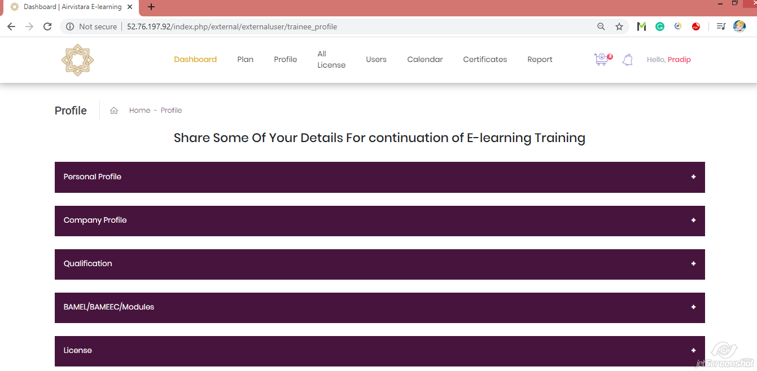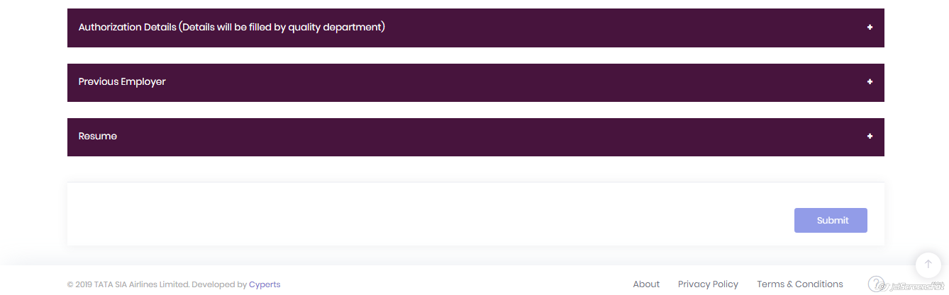

52) Home Page 🡪All Courses

When user select “Individual Plan”, It ask user to select course from Elearning & Onside course list from “All Courses” tab on Dashboard of User Home Page.

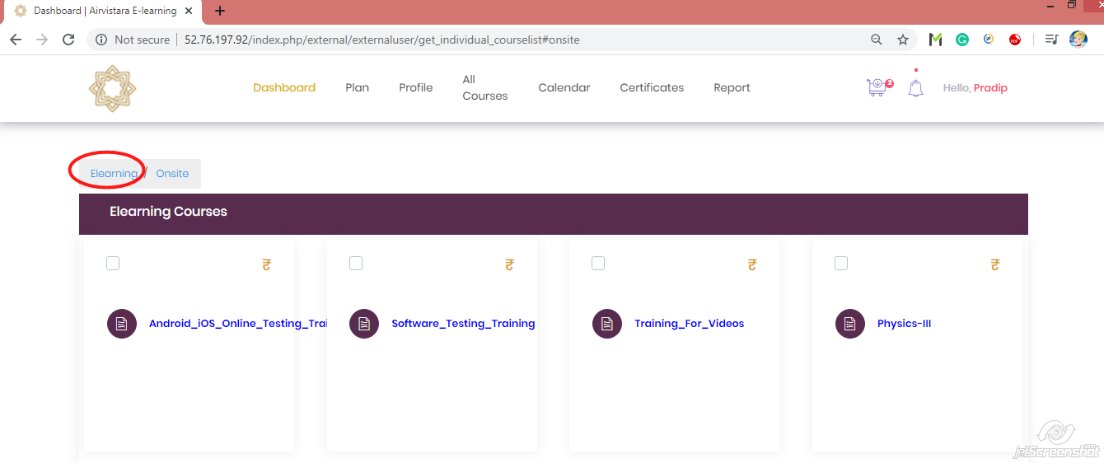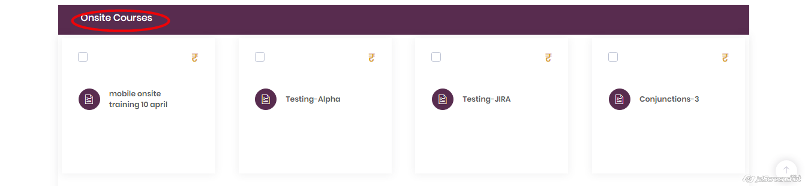

53) Home Page 🡪 All Licenses

When user select “Enterprise Plan” It ask user to purchase “All Licenses” for Elearning courses & Onside course from “All Licenses” tab on Dashboard of User Home Page.

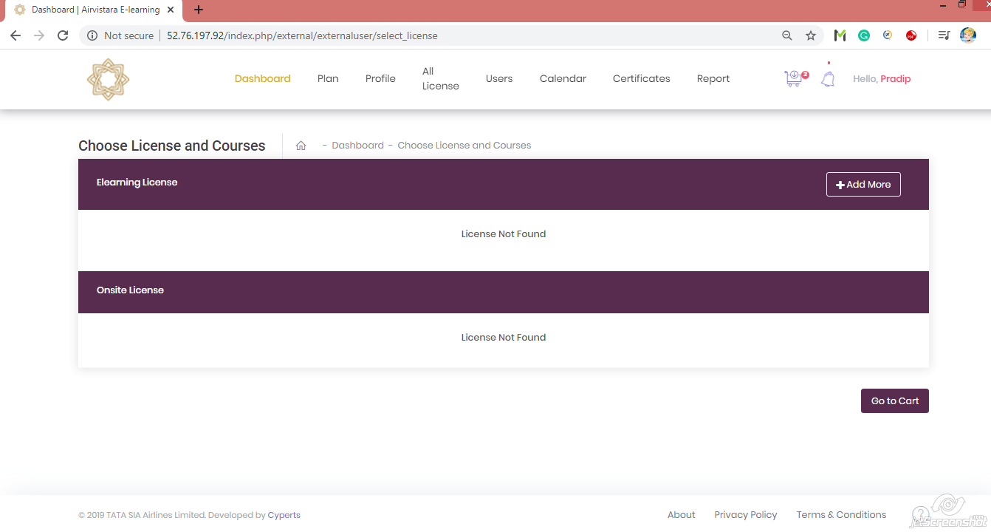

54) Home Page 🡪 All Licenses 🡪 +Add More

When user click on “+Add More” button in “All Licenses” page it directed user on page asking for “Course Name” with “Number Of User” & there “Total Price” to add that course in Cart for Enterprise Users.

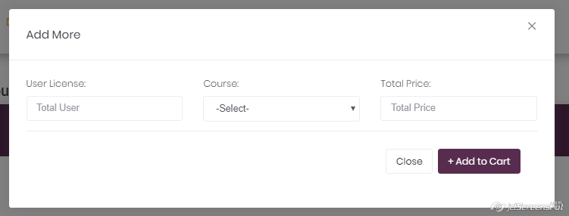

55) Home Page 🡪Users

When user select “Enterprise Plan” It ask user to invite new users for Elearning courses & Onside course by selecting “Users” tab on Dashboard of User Home Page .

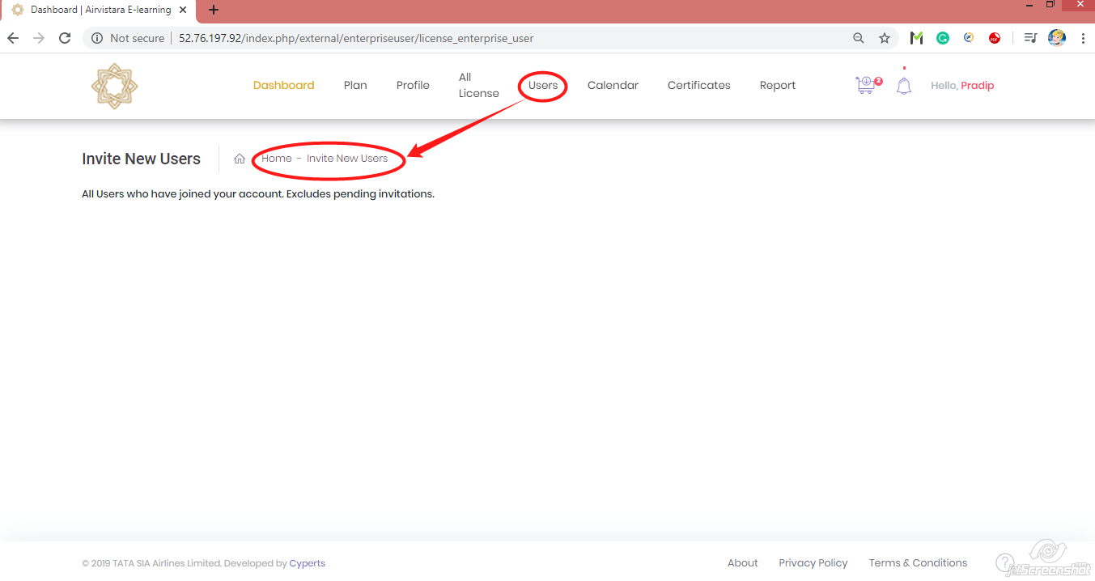

56) Home Page 🡪 Calendar

“Calendar” tab on Dashboard of User Home Page will direct user for calendar showing all schedules of their batches for onside courses with asking to nominate for batch.

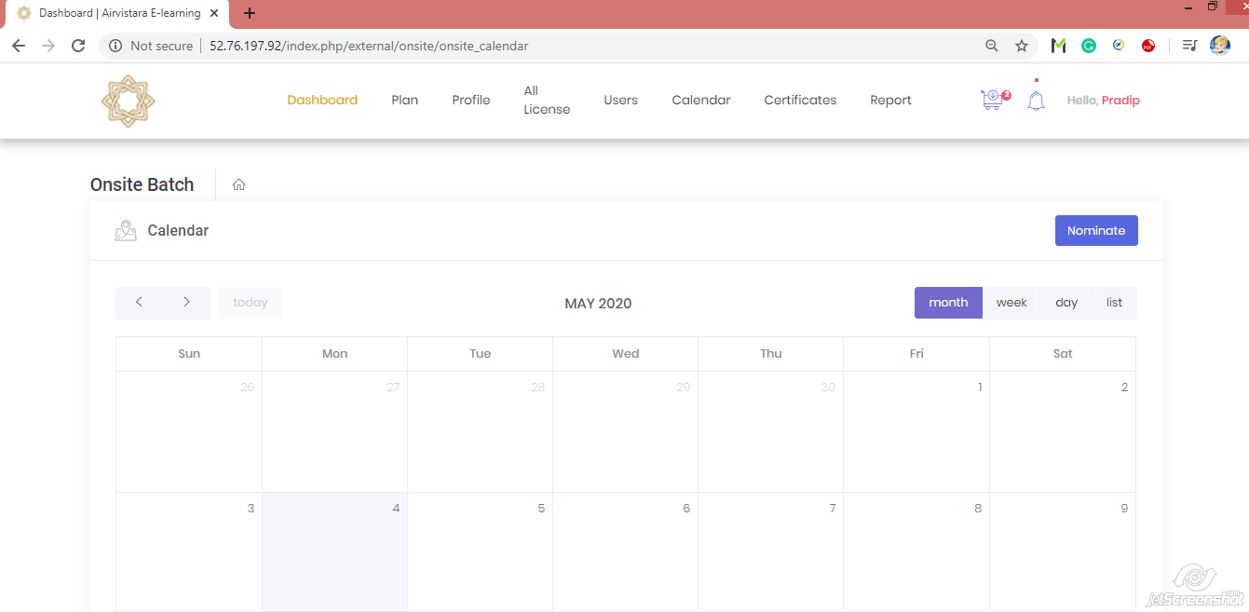

57) Home Page 🡪 Calendar 🡪 Nominate

When user click on “Nominate” button on Calendar it ask Enterprise user for number of users & course with start date & end date of batch to send request for batch to admin.

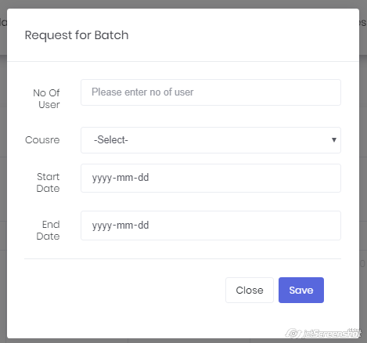

58) Home Page 🡪 My Cart

When user select courses for Elearning or onsite for individual or enterprise user it add that course in “My Cart” for further payment process.

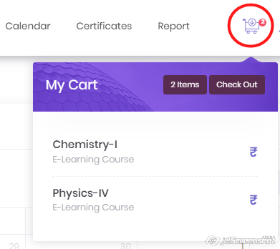

59) Home Page 🡪 My Cart 🡪Check Out

When user click on “Check Out” button in My Cart tab it direct user showing total price for all items in cart & asking user if he/she want to “Add More License” if user is enterprise user for final billing.

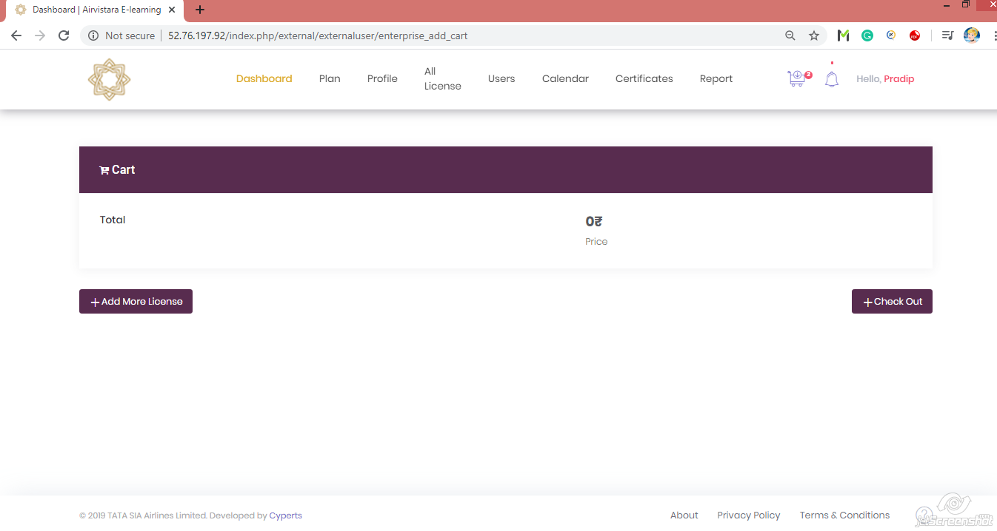

60) Home Page 🡪 My Cart 🡪Check Out

When user click on “Check Out” button in My Cart tab it direct user showing list of courses & asking user if he/she want to “Add More Courses” if user is individual user with “Pay Now” button.

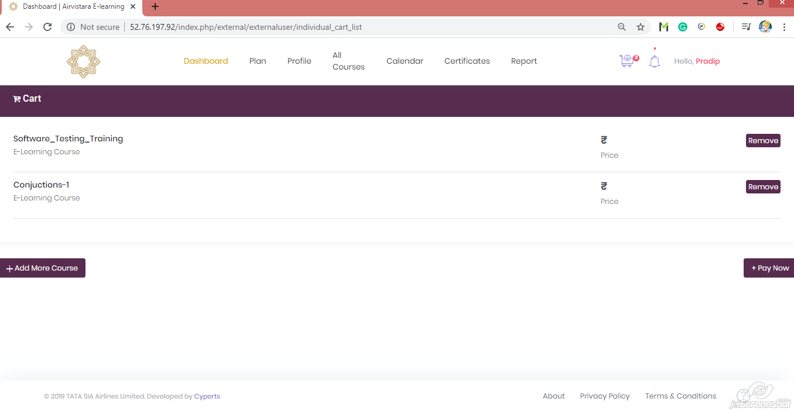

61) Home Page 🡪 My Cart 🡪Check Out 🡪 Pay Now

When user click on “Pay Now” button it will direct user on list of course for elearning & onsite with their number of lessons & when payment process done successfully it open the elearning lessons for user study & plan onsite batch for onsite training.

